Employee Data Analysis Report

Prepared for: Estarta

Prepared by: Omar Alwawi

Date: 4 / 28 / 2026

1. Introduction:

This report analyzes employee data to better understand important aspects of the company’s workforce. The goal is to help management see patterns related to employee retention, diversity, salaries, and bonus distribution.

The analysis focuses on department stability, gender distribution across ethnic groups, the relationship between age and salary, and bonus distribution across departments.

2. Data Overview:

The dataset used in this analysis includes information about employees such as their department, age, gender, ethnicity, salary, bonus percentage, and employment duration.

3. Analysis and Insights:

3.1 Department Stability:

This analysis looks at how stable each department is by considering how long employees stay and how often they leave.

The results show that some departments have higher stability, meaning employees tend to stay longer, while others have lower stability and experience more turnover.

Departments with higher stability are more consistent and may be better for long-term investment, while lower stability may indicate areas that need attention.
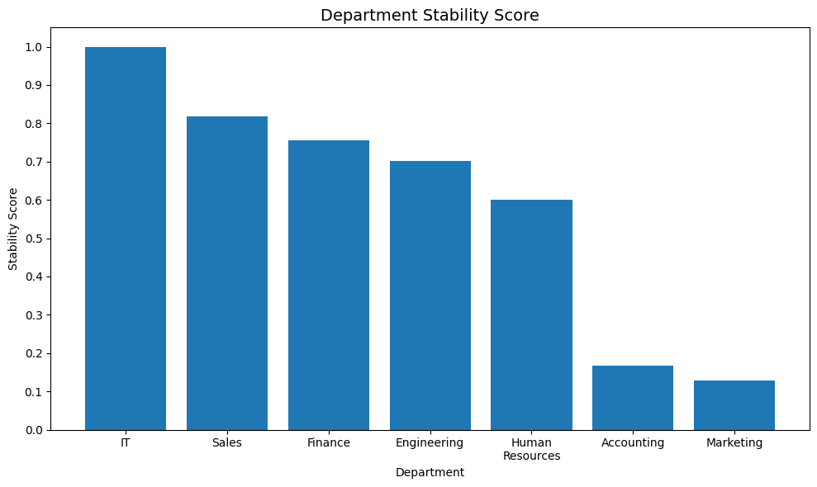Figure 1: Department stability scores based on employee tenure and turnover.

The results show that IT and Sales have the highest stability, indicating stronger employee retention, while Accounting and Marketing show lower stability and may require further attention.

3.2 Workforce Diversity:

This analysis looks at how gender is distributed across different ethnicity groups in the company.

The purpose is to understand whether gender representation is balanced within each group or if some groups are more represented by one gender than the other.

This gives a clearer view of the company’s workforce diversity and helps identify areas that may need more attention.
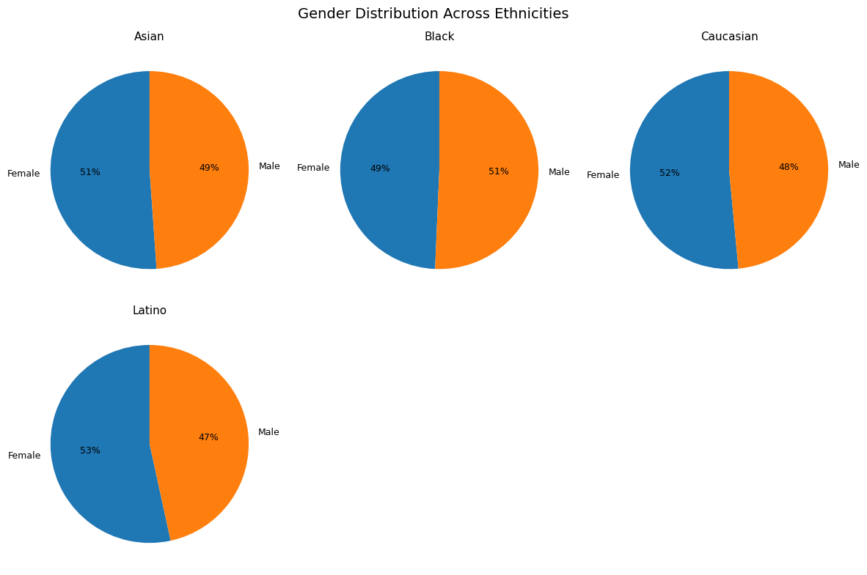

Figure 2: Gender distribution within each ethnicity group.

The results show that ethnicity groups have a balanced gender distribution, indicating fairness in representation.

3.3 Salary vs Age:

This analysis looks at the relationship between employee age and salary.

The goal is to understand whether salary increases as employees get older or if there is no clear pattern between the two.

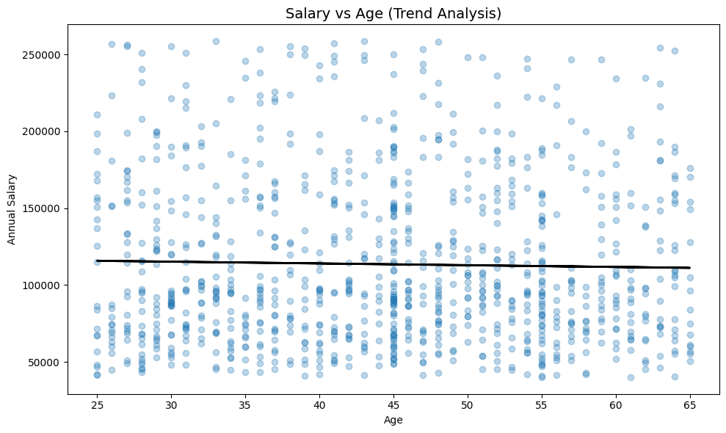
Figure 3: Relationship between employee age and salary.

The results show no relationship between age and salary, indicating that compensation is likely influenced by other factors rather than age. This actually is an issue that we might need to adjust, the age factor is indeed should be affecting the salary slightly keeping in mind the experience that comes with it.

3.4 Bonus by Department:

This analysis looks at how bonus percentages are distributed across different departments.
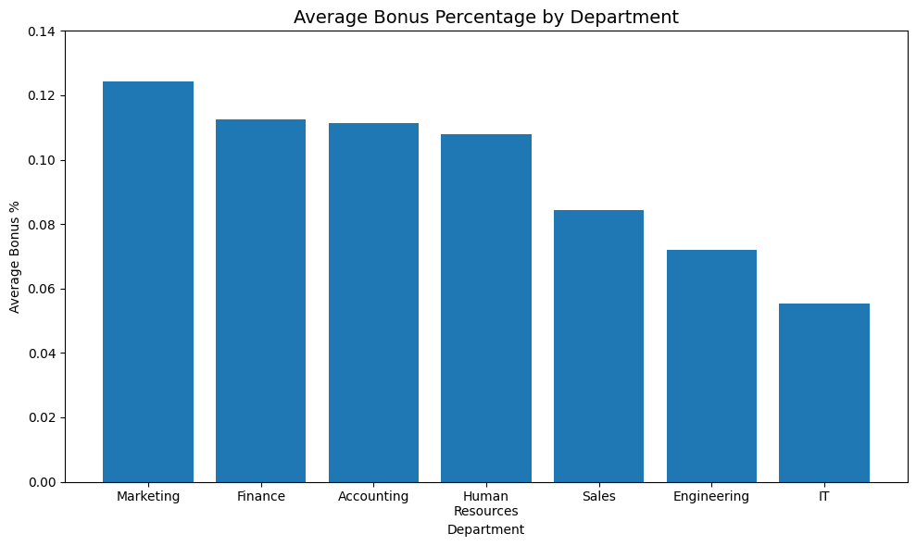

Figure 4: Average bonus percentage by department.

The results show that bonus distribution varies between departments.

4. Key Findings:

- Department stability varies across the company, with some departments showing stronger employee retention than others.

- Gender distribution differs across ethnicity groups, with some groups being more balanced than others.

- No relationship was found between age and salary, suggesting that salary is influenced by other factors more than age.

- Bonus distribution varies between departments, indicating differences in performance incentives across the company.

5. Recommendations:

- Marketing and accounting are by far less stable then other departments, meanwhile the IT department is a stable department but in terms of bonuses the IT is considered the least compensated department, therefore i recommend to consider this on future quarters.
- Monitor diversity across different groups to ensure balanced representation.

- evaluate compensation structures to understand the factors influencing salary differences, taking in considerations the age and experience factor.

6.conclusion:

In conclusion, this report provides an overview of key aspects of the company’s workforce, including stability, diversity, compensation, and incentive distribution.

The analysis highlights important patterns that can support better decision-making and help identify areas for further review.

Overall, the findings offer useful insights that can contribute to improving workforce management and planning.

